X-Random Forest: An Explainable AI Framework for Early Stage Diabetes Prediction with Hyperparameter Tuning and Cross-validation

Md Shahriar Hoque and Osman Gani Mridul
A Thesis in the Partial Fulfillment of the Requirements for the Award of Bachelor of Computer Science and Engineering (BCSE)

Department of Computer Science and Engineering College of Engineering and Technology
IUBAT – International University of Business Agriculture and Technology

Summer 2024
X-Random Forest: An Explainable AI Framework for Early Stage Diabetes Prediction with Hyperparameter Tuning and Cross-validation
Md Shahriar Hoque and Osman Gani Mridul

A Thesis in the Partial Fulfillment of the Requirements for the Award of Bachelor of
Computer Science and Engineering (BCSE)
The thesis has been examined and approved,

__________________________
Prof. Dr. Utpal Kanti Das
Chairman & Professor
Dept. of Computer Science and Engineering
IUBAT – International University of Business Agriculture and Technology

___________________________
Shahinur Alam
Coordinator and Assistant Professor
Dept. of Computer Science and Engineering
IUBAT – International University of Business Agriculture and Technology

___________________________
Faniyam Maria Mansia
Supervisor and Lecturer
Dept. of Computer Science and Engineering
IUBAT – International University of Business Agriculture and Technology

Summer - 2024

Letter of Transmittal
31 October 2024
The Chairman
Thesis Defense Committee
Department of Computer Science and Engineering
IUBAT – International University of Business Agriculture and Technology
4 Embankment Drive Road, Sector 10,
Uttara Model Town, Dhaka 1230, Bangladesh
Subject: Letter of Transmittal.
Dear Sir,
I'm pleased to present my thesis, titled “X-Random Forest: An Explainable AI Framework for Early-Stage Diabetes Prediction with Hyperparameter Tuning and Cross-Validation.” This research addresses the global health challenge of diabetes mellitus, particularly Type 2 diabetes, affecting approximately 422 million people worldwide.
By leveraging machine learning, specifically the Random Forest algorithm, this work aims to improve the accuracy of early-stage diabetes predictions. The thesis emphasizes hyperparameter tuning and cross-validation to enhance model reliability. The ultimate goal is to equip healthcare professionals with effective tools for early detection, supporting better diabetes management and risk reduction.
Thank you for considering this research.
Sincerely
_______________ _______________
Md Shahriar Hoque Osman Gani Mridul
ID: 21103092 ID: 21103005

Student’s Declaration
We, Md Shahriar Hoque and Osman Gani Mridul , students in the BCSE-Bachelor of Computer Science and Engineering program, under the College of Engineering and Technology (CEAT) of the International University of Business Agriculture and Technology (IUBAT), are delighted to announce that this thesis, titled "X-Random Forest: An Explainable AI Framework for Early Stage Diabetes Prediction with Hyperparameter Tuning and Cross-validation", has been prepared for the completion of the CSC 488 thesis course, which is a requirement for the BCSE-Bachelor of Computer Science & Engineering.
We revised the thesis, "X-Random Forest: An Explainable AI Framework for Early Stage Diabetes Prediction with Hyperparameter Tuning and Cross-validation” For this project, every module and step were completed after careful testing and research online.

_______________ _______________
Md Shahriar Hoque Osman Gani Mridul
ID: 21103092 ID: 21103005

Supervisor Certification
This thesis paper entitled “X-Random Forest: An Explainable AI Framework for Early Stage Diabetes Prediction with Hyperparameter Tuning and Cross-validation” is submitted by Md Shahriar Hoque with ID:21103092 and Osman Gani Mridul with ID:21103005 has been accepted as satisfactory in partial fulfillment of the requirement for the degree of Bachelor of Computer Science and Engineering. The report has been prepared under my supervision and is a record of the work accomplished, and completed.

________________________
Faniyam Maria Mansia
Supervisor and Lecturer
Department of Computer Science and Engineering
IUBAT–International University of Business Agriculture and Technology

Abstract
Diabetes currently affects over 422 million people worldwide, presenting a significant global health challenge. While existing methods enable diabetes detection through blood sugar levels, they often require expert analysis and fail to provide insights into the underlying causes and contributing factors. This limitation can result in missed opportunities for preventive measures, potentially leading to an increase in new diabetes cases.
The complexity of diabetes is further compounded by the difficulty of identifying the most critical features among a limited set of factors. This study aims to address these challenges by employing Artificial Intelligence to identify key factors and assess their impact on diabetes onset.
We propose an Explainable Random Forest (XRF) model that achieves an impressive 98.59% accuracy in predicting diabetes status, leveraging hyperparameter tuning and 10-fold cross-validation. Furthermore, our approach enhances the interpretability of the model through Explainable Artificial Intelligence (XAI) techniques. By identifying and emphasizing the most important features, this study seeks to empower potential patients to take preventive measures and assist those already affected in better managing their condition.
Key Index—Explainable Random Forest (XRF), Early Stage Diabetes Prediction, Explainable Artificial Intelligence (XAI), Hyperparameter Tuning, Cross-validation.

Acknowledgments
I would like to express my heartfelt gratitude to all those who have supported me throughout my research on “X-Random Forest: An Explainable AI Framework for Early Stage Diabetes Prediction with Hyperparameter Tuning and Cross-validation.”
First and foremost, I extend my deepest appreciation to my supervisor, Faniyam Maria Mansia, for her invaluable guidance, encouragement, and insightful feedback. Her expertise and unwavering support were instrumental in shaping my research and helping me navigate the complexities of this project.
I am also sincerely grateful to the faculty and staff of the Department of Computer Science and Engineering at IUBAT for fostering an inspiring academic environment and providing the essential resources necessary for my research. A special thanks to my fellow classmates for their camaraderie and collaboration throughout this journey.
Additionally, I would like to acknowledge the contributions of the researchers whose works I reviewed and learned from; their findings significantly informed my study and enriched my understanding of the subject.
Last but certainly not least, I want to express my profound gratitude to my family and friends for their unwavering support, patience, and understanding during the course of my research. Their encouragement has been a constant source of strength and motivation.
This work is dedicated to everyone who has played a part in my academic journey. I sincerely hope that the findings of this research contribute positively to the field of healthcare and diabetes management.

Table of Contents
Letter of Transmittal iii
Student’s Declaration iv
Supervisor Certification v
Abstract vi
Acknowledgments vii
Table of Contents viii
List of Figures x
List of Table xi
Chapter 1. Introduction 12
1.1 Contextual Explanation: 14
1.2 Contributions to the Study: 15
Chapter 2. Literature Review 18
Chapter 3. Research Methodology 25
3.1 Proposed Methodology: 26
3.2 Dataset Description: 27
3.2.1 Key Features of the Dataset: 27
3.2.2 Data Format: 28
3.2.3 Applications: 28
3.2.4 Overview: 28
3.3 Data Preprocess: 28
3.4 Experimental Setup 30
3.5 Trained classiﬁers 31
3.5.1 RandomizedSearchCV: 31
3.5.2 Logistic Regression: 32
3.5.3 Support Vector Machine (SVM): 32
3.5.4 Random Forest (RF): 33
3.5.5 Decision Tree: 33
3.5.6 Extreme Tree (Extremely Randomized Trees): 34
Chapter 4. Result and Discussion 35
4.1 Performance Metrics and Evaluation 36
4.2 Performances of ML Architectures 36
4.3 Comparative Performance Metrics for Classifiers: 39
4.4 Confusion Matrix & ROC Curve for All Classifiers 39
4.5 Explainable Artificial Intelligence (XAI) 42
1) XAI for Interpreting Black-Box Models 42
2) XAI for Feature Importance 45
4.6 Discussion and Extended Comparison 47
Chapter 5. Conclusion and Future Work 48
5.1 Conclusion 49
5.2 Limitations 50
5.3 Future Work 52
5.4 References 54

List of Figures
Fig 3.1 An overview of the proposed method for Early stage Diabetes Risk Prediction…………..……26
Fig 4.1: Decision Tree (DT)Confusion Matrix & ROC Curve………………………….……………….39
Fig 4.2: Extra Tree (ET)Confusion Matrix & ROC Curve………………………………………………40
Fig 4.3: Logistic Regression (LR)Confusion Matrix & ROC Curve…………………….………………40
Fig 4.4: Random Forest (RF)Confusion Matrix & ROC Curve. ………………………………………..40
Fig 4.5: Support Vector Machines (SVM)Confusion Matrix & ROC Curve……………………………41
Fig 4.6: ROC Curve for All Classifier………………………………………………………………..….41
Fig. 4.7. SHAP Explanation (RF)…..……………………………………………………………………43
Fig. 4.8. LIME Explanation (SVM)…….………………………………………………………………..44
Fig. 4.9. Explanation by IG (RF)..……………………………………………………………………….44
Fig. 4.10. ICE of RF Classifier…………………………………………………………………………..46
Fig. 4.11. PFI of RF Classifier…………………………………………………………………………...46

List of Table
Table 4.3 of Comparative Performance Metrics for Classifiers……………………………….……….39
Table 4.7 Discussion and Extended Comparison…………………………………………………...…..47

Chapter 1. Introduction

Diabetes mellitus, particularly Type 2 diabetes, is an escalating global health crisis characterized by chronically elevated blood glucose levels, primarily resulting from obesity and insulin dysfunction. As the metabolism of carbohydrates becomes disrupted, patients often experience significant health complications, including damage to vital organs, cardiovascular diseases, and neuropathy. According to the World Health Organization (WHO), approximately 422 million individuals are affected by diabetes worldwide, with prevalence rates sharply increasing, especially in low- and middle-income countries. Alarmingly, projections estimate that by 2030, the number of people living with diabetes could reach 490 million【1】. In Europe alone, diabetes accounted for nearly 186,000 deaths in 2019【2】. Countries such as India, Canada, and China report notably high prevalence rates, with India alone housing over 40 million individuals diagnosed with diabetes. These staggering statistics highlight the urgent need for enhanced diagnostic and management strategies in the fight against this chronic disease.
Traditionally, the diagnosis of early-stage diabetes has relied heavily on human expertise, which can be prone to inconsistencies and errors. Although current methodologies provide essential insights into patient health, they often lack the precision required for timely and accurate detection. In contrast, machine learning (ML) methodologies present a transformative approach to diabetes prediction by harnessing large datasets to improve predictive accuracy. This study aims to explore cutting-edge ML techniques that facilitate early detection and intervention, thereby enhancing patient outcomes and promoting preventative healthcare.
Despite previous research investigating various algorithms for diabetes prediction, several challenges remain. This study specifically focuses on the Random Forest algorithm, which is renowned for its robustness and accuracy in classification tasks. We emphasize critical enhancements in cross-validation and hyperparameter tuning to refine the algorithm's predictive capabilities and address existing limitations.
Through a comprehensive review of recent literature, this study evaluates the performance of various machine learning models, including Support Vector Machines, Artificial Neural Networks, and innovative algorithms such as Extreme Learning Machines. By comparing the applicability and effectiveness of these models, we aim to underscore the potential of integrating advanced machine learning techniques into clinical practice. Ultimately, this research seeks to improve early diagnosis and inform intervention strategies, thereby contributing to better management of diabetes mellitus and mitigating its associated health risks.

1.1 Contextual Explanation:
In recent years, the intersection of machine learning and explainable artificial intelligence (XAI) has garnered significant attention in the medical field, particularly in the prediction and management of chronic diseases like diabetes.
RQ1 seeks to explore how the integration of machine learning algorithms with XAI can enhance the accuracy of diabetes predictions. By analyzing regular lifestyle data—such as dietary habits, physical activity levels, and biometric information—machine learning models can identify patterns and correlations that traditional diagnostic methods may overlook. The focus on XAI is crucial, as it provides transparency to the decision-making process of machine learning algorithms, enabling healthcare professionals to understand and trust the predictions generated.
RQ2 delves into the implications of insights gained from XAI in the context of diabetes prevention. By elucidating key factors that contribute to diabetes risk, XAI not only enhances predictive models but also empowers individuals and healthcare providers to take preventive actions. Understanding the rationale behind predictions allows for informed decision-making and the implementation of targeted interventions tailored to individual risk profiles.
Together, these research questions aim to bridge the gap between advanced computational techniques and practical healthcare applications, ultimately contributing to improved outcomes in diabetes management and prevention.

1.2 Contributions to the Study:
The research questions outlined in this study are meticulously addressed, leading to several significant contributions that enhance the understanding and management of diabetes through machine learning and explainable artificial intelligence (XAI).
Data Preprocessing: The dataset has undergone a rigorous preprocessing phase to ensure optimal quality for subsequent training and testing. This process includes data cleaning, which involves the removal of inconsistencies, missing values, and outliers that could skew the results. This step is critical to ensuring the integrity of the data. Additionally, normalization techniques are applied to standardize the scale of features, which is essential for algorithms sensitive to the magnitude of input data. Furthermore, relevant features are identified and selected to enhance the predictive power of the model, achieved through techniques such as correlation analysis and recursive feature elimination.
X-RF Model Utilization: The study employs the X-RF (eXplainable Random Forest) model, optimized through advanced hyperparameter tuning to maximize predictive accuracy. Key aspects of this utilization include performance benchmarking, where the X-RF model's effectiveness is rigorously compared against four other classifiers, including traditional machine learning algorithms like Support Vector Machines (SVM) and Logistic Regression, as well as more complex models like Artificial Neural Networks (ANN). This comparative analysis highlights the X-RF model’s superior predictive capability, enabling healthcare practitioners to make informed decisions based on reliable predictions. The study also underscores the model’s potential for real-world application in clinical settings, aiding in early diabetes detection and intervention.
Mitigation of Overfitting: To combat the risk of overfitting, a robust 10-fold cross-validation technique is implemented. This process involves partitioning the dataset into ten subsets, with the model trained on nine and validated on the remaining one, rotating this process across all subsets. This thorough validation technique provides a comprehensive assessment of the model’s generalization capability, enhancing confidence in its performance and ensuring that the model remains effective when applied to unseen data.
Dual Approach to Explain ability: A dual approach to explain ability is employed, incorporating seven distinct XAI methods to elucidate the black-box nature of the machine learning algorithms. Techniques such as SHAP (SHapley Additive exPlanations) and LIME (Local Interpretable Model-agnostic Explanations) are utilized to interpret model predictions, helping stakeholders understand how specific features influence the model’s output. This fosters trust in the automated predictions and enhances the clinical understanding of diabetes risk, providing valuable insights for healthcare providers to tailor prevention strategies.
Guidance from XAI Insights: The insights derived from the XAI methodologies not only highlight the significant features contributing to diabetes prediction but also inform precautionary measures. This knowledge empowers various stakeholders. For individuals with diabetes, the insights allow patients to monitor key health indicators and adopt lifestyle changes that mitigate their risk. For at-risk individuals, awareness of the critical factors influencing diabetes onset enables proactive measures, such as dietary adjustments and regular health screenings. Moreover, the study provides actionable insights for healthcare practitioners that can inform patient education and preventive healthcare initiatives, leading to improved outcomes and reduced healthcare costs.
Through these contributions, this study not only advances the understanding of diabetes prediction utilizing machine learning and XAI but also lays a robust foundation for practical applications in preventive healthcare. The integration of advanced predictive modeling with explainability enhances the potential for early diagnosis, personalized patient care, and a proactive approach to diabetes management.

Chapter 2. Literature Review

The field of undergraduate admission test surveys is underexplored, with few studies making notable contributions. This section examines their insights and limitations, despite differing datasets from our research.
Kopitar et al. [1] conducted a comparative study of machine learning algorithms—Glmnet and Random Forest (RF)—against traditional regression models for predicting fasting plasma glucose levels using a dataset of 27,050 adult electronic health records (EHRs) from individuals without a prior diagnosis of Type 2 Diabetes Mellitus (T2DM), collected between December 2014 and September 2017. The study found that RF had a lower root mean square error (RMSE) of 0.842 compared to Glmnet's 0.859, demonstrating greater stability in variable selection, indicating its robustness with complex datasets. Despite the promise of machine learning models, the researchers noted that traditional regression models might be more suitable in clinical settings due to their interpretability and stability. This research highlights that while advanced models like Glmnet and RF show potential, simpler regression models are often preferable for practical clinical applications, where the ability to clearly understand and explain predictions is crucial.
Kaur and Kumari [2] evaluated five machine learning models—linear kernel support vector machine (SVM), radial basis function (RBF) kernel SVM, k-nearest neighbors (k-NN), artificial neural networks (ANN), and model-based recursive feature elimination (MDR)—for early diabetes detection using the Pima Indian Diabetes dataset. Their study identified the linear kernel SVM as having the highest accuracy (0.89), while k-NN achieved the best recall (0.90), indicating its effectiveness in identifying positive cases. They applied the Boruta feature selection algorithm, which improved model performance, emphasizing the critical role of feature selection in predictive modeling. However, they noted that the visualization of selected features was not adequately addressed. The study underscores the importance of early diabetes detection in preventing health complications, emphasizing that linear kernel SVM and k-NN are particularly effective classifiers for this purpose. The analysis further emphasizes the significance of data preprocessing and performance evaluation using metrics like accuracy, recall, precision, F1 score, and AUC, demonstrating the potential of machine learning models in healthcare applications.
Yasir et al. [3] reviewed various machine learning methods for diabetes prediction, emphasizing the importance of feature selection and algorithm choice in improving prediction accuracy. Their study demonstrated that the Random Forest (RF) algorithm achieved a high accuracy of 97.4% with 10-fold cross-validation and 98% on the Sylhet Diabetes Hospital dataset. Additionally, using principal component analysis (PCA) with RF yielded an 80.84% accuracy, while quantum particle swarm optimization (QPSO) and weighted least squares SVM (WLS-SVM) were also explored. The combination of the Crow Search Algorithm with feed-forward neural networks resulted in the highest accuracy, reaching 99.04%. Despite these findings, the study lacked methods to visualize the most influential features. The analysis highlights the potential of optimization algorithms like particle swarm optimization and tree seed algorithm in feature classification, stressing the significance of selecting the right classification methods for effective early diabetes diagnosis.
Khafaga et al. [4] highlighted the effectiveness of the Extreme Learning Machine (ELM) model for diabetes prediction, achieving an accuracy of 98.07% using questionnaire data on the Early-Stage Diabetes Risk Prediction dataset. The study emphasized the model's suitability for resource-constrained settings due to its low cost and user-friendly design, making it particularly valuable in rural and underserved areas. This approach addresses healthcare access challenges, especially during the COVID-19 pandemic, by offering a simple tool for early diabetes risk assessment. However, the study noted a lack of focus on the model's explainability.
Elsayed et al. [5] underscored the global challenge of diabetes and the urgent need for early detection through machine learning. They highlighted the effectiveness of algorithms such as support vector machines (SVM) and decision trees, reporting a 90.04% accuracy by integrating K-Means with the J48 algorithm on the Early-Stage Diabetes Risk Prediction dataset. Additionally, Yu et al. achieved an AUC of 83.5% with SVM. The study identifies a research gap in combining classification algorithms with association rules to enhance prediction accuracy. It also explores various data mining techniques, achieving a notable accuracy of 97.36% with the k-nearest neighbors (KNN) algorithm, emphasizing the importance of early detection for better healthcare decision-making.
Wijayaningrum and Saragih [6] demonstrated the effectiveness of multi-layer perceptron (MLP) models in early-stage diabetes prediction, achieving 92.66% accuracy with one hidden layer and 93.18% with two hidden layers on the PIMA Indian Diabetes Dataset. They further optimized MLP performance using the Improved Crow Search Algorithm (ICSA), resulting in an impressive accuracy of 97.69%, surpassing traditional algorithms like J48 and Naïve Bayes. This highlights the critical role of hidden layers and parameter optimization in enhancing predictive accuracy. The study suggests that incorporating more advanced optimization techniques and exploring deeper network architectures could further improve MLP performance, making it a viable option for early diabetes detection in clinical settings. Overall, the findings emphasize the potential of MLP models to contribute significantly to diabetes risk assessment and management strategies.
The review by Ergün et al. [7] evaluates eight machine learning methods for early-stage diabetes prediction, including convolutional neural networks (CNN), XGBoost, and Naive Bayes. The CNN achieved the highest accuracy of 99.04%, followed by XGBoost at 97.89% on the Early-Stage Diabetes Risk Prediction dataset. The study emphasizes the effectiveness of these algorithms in early diabetes detection and the importance of comprehensive datasets from the UCI Machine Learning Repository. While the models demonstrated high predictive accuracy, the interpretability of CNN and XGBoost remains a challenge. The research utilized a dataset with 16 features from 520 individuals, identifying key predictors such as age and polydipsia, and suggests further development of a diabetes risk prediction application based on the CNN model.
In their review, Zarar and Wang [8] examine the effectiveness of various machine learning algorithms for diabetes prediction, emphasizing the impressive performance of artificial neural networks (ANN), which achieved an accuracy of 98.8% on both the PIMA Indian Diabetes and Kaggle Diabetes datasets. Additionally, Random Forest and Support Vector Machine demonstrated strong results, with Random Forest attaining an accuracy of 94.10%. The authors highlight the challenges posed by data scarcity and the potential biases introduced by imbalanced datasets. They advocate for the use of comprehensive evaluation metrics to assess model performance effectively and suggest future research avenues, such as employing these models in image processing for non-invasive diabetes prediction and investigating diabetes risk among non-diabetic individuals.
Vakil and Pachchigar [9] conducted a review assessing various machine learning algorithms for early-stage diabetes prediction, finding that Random Forest achieved the highest accuracy of 99% on the Early-Stage Diabetes Risk Prediction dataset. Their study highlights the significance of "polyuria" as a key feature influencing predictions across different models, based on SHAP values. The authors emphasize the need for explainable AI to enhance the interpretability and trustworthiness of diabetes prediction models. The paper presents a comparative analysis of several algorithms, including decision tree, artificial neural networks (ANN), k-nearest neighbor (KNN), support vector machine (SVM), and XGBoost, reinforcing the critical role of early diagnosis in preventing severe health consequences associated with diabetes. Furthermore, they advocate for the integration of explainable AI to build confidence in AI-driven healthcare solutions.
Abushawish and Nassif [10] highlight the effectiveness of various machine learning techniques in diabetes diagnosis, reporting that Random Forest achieved up to 98.49% accuracy, while Support Vector Machines reached 96.4% using data from Sylhet Diabetes Hospital, which includes information from 520 individuals with diabetes-related symptoms. The study notes that Naïve Bayes and K-Nearest Neighbors (KNN) showed lower accuracies, although KNN achieved up to 100% in some instances. The authors emphasize the critical role of feature selection and model evaluation metrics in enhancing prediction accuracy and facilitating early detection of diabetes.
Refat et al. [11] conducted a comparative analysis of discriminant analysis and logistic regression for predicting early-stage diabetes using a dataset from the UC Irvine Machine Learning Repository. They found that discriminant analysis significantly outperformed logistic regression, achieving an ROC area of 0.837 compared to 0.527. While logistic regression identified important variables, its overall predictive performance was limited. The study underscores the importance of exploring diverse classification methods to enhance prediction accuracy and emphasizes the need for early detection to prevent serious health complications.
Gündoğdu et al. [12] introduced a hybrid model (MLR-RF-XG) for early-stage diabetes prediction that achieved an impressive accuracy of 99.23% with minimal computational demands on the PIMA Diabetes dataset. The study emphasizes the critical role of feature selection in enhancing diagnostic accuracy, although it also acknowledges limitations such as the small dataset and the necessity for broader validation. Additionally, it highlights the potential of using questionnaire data to reduce reliance on invasive testing methods. The review further discusses various research studies that apply machine learning, data mining, and deep learning techniques in healthcare, particularly for diabetes prediction and COVID-19 diagnosis, underscoring the need for effective feature selection and the importance of validating results with medical professional.
Samet et al. [14] demonstrated that a hybrid model achieved 90.62% accuracy on the PIMA Diabetes dataset, outperforming individual methods like Naive Bayes (76.30%) and SVM (77%), showcasing the advantages of combining algorithms. The review highlights the effectiveness of various machine learning models, such as Decision Trees and Artificial Neural Networks (ANNs), in identifying diabetes risk patterns. It emphasizes the potential of these models to improve prediction accuracy and efficiency in diabetes management. The paper also stresses the need for advanced predictive methods due to the rising prevalence of diabetes, suggesting future research should focus on larger datasets and include additional lifestyle factors to refine prediction accuracy.
Chen et al. [15] conducted a comprehensive investigation into the factors influencing the progression from normal glucose levels to prediabetes and diabetes, identifying key risk factors such as age, body mass index (BMI), and specific biochemical markers. Their findings revealed that logistic regression outperformed machine learning models in predicting these transitions, achieving AUC values exceeding 0.7, while also emphasizing the significance of physical examination indicators in enhancing predictive accuracy. Despite utilizing a substantial dataset of 5,127 subjects (1,582 normal, 2,929 prediabetes, and 616 diabetes), the study noted a lack of detailed descriptions in the cited studies, underscoring the need for further research to refine prediction models and validate the findings across diverse populations. Overall, the study highlights the importance of urine tests and physical examination indicators in predicting diabetes risk and suggests that additional research could enhance the reliability of these predictive models.

Chapter 3. Research Methodology

The research employs the Early Stage Diabetes Risk Prediction Dataset to train an Explainable Random Forest (X-RF) architecture, following a systematic methodology that encompasses data preprocessing, model development, hyperparameter optimization, and performance evaluation. Each step is essential for ensuring the effectiveness of the predictive model in accurately identifying diabetes risk.
The research begins with creating and preprocessing a new dataset, which is then split into 10 folds of subsets. FT-SVM architectures are trained using a 10-fold cross-validation method, where each fold is used as a testing set once. Model performance is evaluated during each round and compared with other classifiers. Four XAI techniques interpret the SVM model, while three additional methods identify key features influencing predictions.

3.1 Proposed Methodology:
Our proposed model is given below:
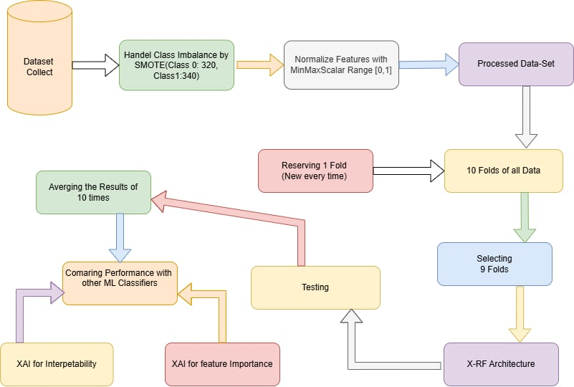
Figure 3.1: An overview of the proposed method for early stage Diabetes Risk Prediction

3.2 Dataset Description:

The Early Stage Diabetes Risk Prediction Dataset, accessible from the UCI Machine Learning Repository [16], serves as a pivotal resource for researchers and practitioners in the field of healthcare and predictive analytics. This dataset comprises 520 records, each meticulously curated to include essential health-related variables critical for assessing the risk of developing diabetes.

3.2.1 Key Features of the Dataset:
- Age: The age of individuals is recorded in years, allowing for an analysis of how age correlates with diabetes risk.
- Body Mass Index (BMI): BMI is a numerical value derived from height and weight measurements, indicating whether individuals are underweight, normal weight, overweight, or obese. This metric is crucial for understanding obesity-related risks associated with diabetes.
- Glucose Levels: Fasting blood glucose levels are measured in mg/dL, providing insights int blood sugar regulation and its implications for diabetes risk.
- Polyuria: This feature indicates the presence of excessive urination, a common symptom associated with diabetes. It is coded as a binary variable (e.g., 0 for no, 1 for yes).
- Polydipsia: This feature denotes excessive thirst, another symptom linked to diabetes, also represented as a binary variable.
- Additional Health Metrics: The dataset may also include other relevant features such as insulin levels, family history of diabetes, or physical activity levels, depending on the specific dataset variant used.

3.2.2 Data Format:
Numerical Representation: All data entries in the dataset are formatted as numerical values, ensuring consistency and compatibility with various analytical methods. This numerical format facilitates easy data manipulation and statistical analysis.
3.2.3 Applications: This dataset is particularly valuable for developing and evaluating machine learning models aimed at predicting diabetes risk. It enables researchers to explore relationships between various health metrics and diabetes outcomes, offering insights that can inform preventive health measures and lifestyle modifications.
3.2.4 Overview: Table I provides a detailed summary of the dataset, including the distribution of each feature, statistical summaries (mean, median, mode), and any notable patterns or trends observed within the data. The dataset's structure and the information it contains make it an ideal candidate for predictive modeling, hypothesis testing, and further research in diabetes risk assessment.

3.3 Data Preprocess:
The preprocessing phase involves several critical steps designed to prepare the dataset for effective model training:
- Addressing Class Imbalance:
  - The original dataset contains 320 samples for class ‘1’ (indicating diabetes risk) and 200 samples for class ‘0’ (indicating no risk). This results in a class imbalance that can bias model predictions toward the majority class.
  - To mitigate this issue, the Synthetic Minority Over-sampling Technique (SMOTE) is utilized. SMOTE generates synthetic samples for the minority class (class ‘0’), thereby equalizing the class distribution to 320 samples for each class. This balance is crucial for training a robust model capable of generalizing well to unseen data.
- Separation of Class Labels and Features:
  - After addressing class imbalance, class labels are separated from feature attributes to facilitate model training. This ensures that the model learns from the features while the labels serve as targets for prediction.
  - The feature set typically includes various health indicators relevant to diabetes risk, such as glucose levels, BMI, age, and family history.
- Normalization of Feature Variables:
  - To ensure consistency and comparability across the dataset, feature variables are normalized to a range between 0 and 1 using the MinMaxScaler. This step is essential as it mitigates the effects of differing scales among features, enhancing training efficiency.
  - The MinMaxScaler operates on each feature individually, applying the formula:
$$X^{'}=\frac{\left(X - X_{min}\right)}{X_{\max{-}X_{min}}}$$

Here, $X$represents the original feature value, $X_{min}$and $X_{max}$ minimum and maximum values within the training set, respectively, and X′ is the resulting scaled value. This normalization ensures that all features contribute equally to the model's learning process.

3.4 Experimental Setup
The architecture for this study was developed and executed on Google Colaboratory, a cloud-based platform that offers an accessible and powerful environment for data analysis and machine learning experiments. The specific configuration utilized during the experiments is as follows:
- Platform: Google Colaboratory
- Processor: Intel Xeon processor with 2 virtual CPUs (vCPUs)
- Memory: 12GB of RAM
The choice of Google Colaboratory is advantageous for several reasons:
- Accessibility:
  - Google Colaboratory allows for easy sharing and collaboration, enabling multiple users to work on the same notebook simultaneously. This fosters an environment conducive to teamwork and peer reviews, facilitating immediate feedback and iterative improvements in model development.
- Free Resources:
  - The platform provides free access to GPUs and TPUs. In this study, the default CPU configuration was utilized to run experiments efficiently without incurring additional costs, making it feasible for researchers and students to conduct extensive experiments without financial constraints.
- Pre-installed Libraries:
  - Google Colaboratory is equipped with numerous pre-installed libraries and frameworks essential for data science and machine learning, including Scikit-learn, Pandas, NumPy, and Matplotlib. This significantly reduces setup time, allowing researchers to focus on model development and analyses without the overhead of manual installations.
- Integrated Environment:
  - The notebook interface supports interactive coding, enabling real-time visualization and debugging. This feature is particularly useful for experimenting with different data preprocessing techniques and model configurations, allowing for immediate validation of results.

C. Hyperparameter Tuning Procedure
For each classifier employed in this research, the RandomizedSearchCV technique was utilized to identify the optimal hyperparameters. This technique is effective for tuning machine learning models, as it allows for a more efficient exploration of the hyperparameter space compared to exhaustive search methods.

3.5 Trained classiﬁers
For our Early Stage Diabetesprediction research, we used an in-depth set of machine learning algorithms to identify the most accurate and dependable model for predicting diabetes. The methods that have been deployed include Logistic Regression, SVM, Decision Tree, Extra Tree, Random Forest. Each model was selected for its unique ability to deal with different parts of the dataset and prediction challenges. Here is an overview of each classifier:
3.5.1 RandomizedSearchCV: RandomizedSearchCV conducts a random search over specified hyperparameter values, sampling a fixed number of parameter settings from defined distributions. This balances exploration and computational efficiency, enabling quicker convergence to optimal settings. By sampling rather than exhaustively searching all combinations, the approach reduces computation time while still discovering high-performing configurations.
3.5.2 Logistic Regression: Logistic Regression is a widely-used linear model for binary classification that models the probability of a given instance belonging to a particular class. Instead of predicting the outcome directly, Logistic Regression applies a logistic function to ensure that predictions fall within the [0, 1] range, which represents the probability of an instance belonging to a class. This makes it particularly useful for problems where the output needs to be a probability or binary decision.
Formula:$\hat{Y}=\frac{1}{1+e^{-\left(β_{0}+β_{1}X_{1}+β_{2}X_{2}+…+β_{n}X_{n}\right)}}$
​ where:
- $\hat{Y}$ is the predicted probability that the instance belongs to the positive class.
- e is the base of the natural logarithm.
- $β_{0}$​ is the intercept term.
- $β_{1},β_{2},…,β_{n}$ are the coefficients for each feature in the dataset.
- $X_{1},X_{2},…,X_{n}$are the features in the dataset
Logistic Regression is simple and interpretable but may not capture complex relationships well.
3.5.3 Support Vector Machine (SVM):Support Vector Machine is a powerful classification algorithm that works by finding the hyperplane that best separates data points of different classes with the largest margin possible. SVM is particularly effective in high-dimensional spaces and works well when there is a clear margin of separation between classes.
Formula:
For a linear SVM, the decision boundary is determined by:
$$f\left(X\right)=\text{sign}\left(\vec{w}⋅\vec{X}+b\right)$$
where:
- f(X) is the classification function that predicts the class label (+1 or -1).
- $\vec{w}$ is the weight vector perpendicular to the hyperplane?
- $\vec{X}$represents the feature vector.
- b is the bias term that adjusts the position of the hyperplane.
To maximize the margin, SVM minimizes ∥w⃗∥ under the constraint that all points satisfy:
$$y_{i}\left(\vec{w}⋅\vec{X_{i}}+b\right)≥1$$
where $y_{i}$​ represents the true class labels (either +1 or -1) for each data point $X_{i}$
SVMs can also handle non-linearly separable data by using kernel functions to map data into higher-dimensional spaces, allowing for complex decision boundaries.
3.5.4 Random Forest (RF): A group technique for learning that creates multiple decision trees for training and average the results to increase accuracy and reduce overfitting. Random Forests are stable to movement and manage high-dimensional data correctly.
Formula: Y^=$\frac{1}{N}\sum_{i=1}^{N}{T_{i}\left(X\right)}$
Where:
- T_{i} (X) is the prediction from the i^{th} decision tree.
- N is the total number of trees.
- Y^\hat{Y} is the final predicted sales.
3.5.5 Decision Tree: A Decision Tree is a tree-based model that makes decisions by splitting the dataset into branches based on feature values, leading to predictions at the leaf nodes. Each internal node represents a decision based on a feature, each branch represents an outcome of that decision, and each leaf node represents a predicted class or value. Decision Trees are easy to interpret but can overfit if not pruned properly.
Formula:
$$\hat{Y}=\frac{1}{\left|S_{j}\right|}\sum_{i∈S_{j}}{y_{i}}$$
Where:
- $\hat{Y}$ is the predicted value at that leaf node.
- $S_{j}$is the subset of training data assigned to leaf node j
- $y_{i}$are the actual target values of instances within $S_{j}$
3.5.6 Extreme Tree (Extremely Randomized Trees):Extra Trees, or Extremely Randomized Trees, are an ensemble learning method that builds multiple decision trees, but with added randomness at each split. Unlike standard decision trees, Extra Trees use random splits of the data, even if they’re not the best splits, which helps reduce variance and often leads to better generalization.
Formula:
$$\hat{Y}=\frac{1}{K}\sum_{k=1}^{K}{T_{k}\left(X\right)}$$
Where:
- $K$ is the total number of trees in the ensemble.is the loss function.
- $T_{k}\left(X\right)$represents the prediction from the $k$-th tree for input $X$
- $\vec{y}$is the averaged prediction across all trees.

Chapter 4. Result and Discussion

4.1 Performance Metrics and Evaluation
To evaluate the performance of each model, various metrics were utilized, including:
- Accuracy: The proportion of correct predictions made by the model.
- Precision: The ratio of true positive predictions to the total predicted positives, indicating the quality of positive predictions.
- Recall (Sensitivity): The ratio of true positives to the total actual positives, reflecting the model's ability to identify all relevant cases.
- F1 Score: The harmonic mean of precision and recall, providing a balance between the two metrics.
- ROC-AUC Score: A metric that evaluates the model's ability to distinguish between classes, with higher values indicating better performance.
These metrics were calculated for each classifier after the hyperparameter tuning process and averaged over a 10-fold cross-validation approach to ensure robust and reliable evaluation results.

4.2 Performances of ML Architectures
In this section, we conduct a comparative analysis of the performance metrics across various classifiers to pinpoint the most effective model for predicting diabetes risk. The following provides a detailed overview of the performance of several classifiers based on critical performance metrics:
- Random Forest (RF) Classifier:
  - Accuracy: 98.59%
  - F1-Score: 98.58%
  - Precision: 98.76%
  - Recall: 98.43%
  - Specificity: 98.75%
- The RF classifier emerges as the top-performing model, achieving the highest accuracy and F1-Score among the classifiers evaluated. Its high precision (98.76%) and recall (98.43%) illustrate its effectiveness in capturing true positive cases, while a specificity of 98.75% indicates reliability in identifying negative instances. The ensemble nature of RF, combining multiple decision trees, helps reduce overfitting and enhance predictive accuracy, particularly in complex datasets.
- Extra Trees (ET) Classifier:
  - Accuracy: 98.59%
  - F1-Score: 98.58%
  - Precision: 98.75%
  - Recall: 98.75%
  - Specificity: 98.59%
- The ET classifier closely follows RF, matching its accuracy and F1-Score. ET demonstrates strong recall, indicating effective identification of positive cases, with a specificity reflecting reliability in classifying negative cases. The slight variations in precision and specificity reflect the inherent differences in how these algorithms handle data.
- Support Vector Machine (SVM):
  - Accuracy: 96.87%
  - F1-Score: 96.91%
  - Precision: 97.16%
  - Recall: 96.87%
- The SVM exhibits solid performance, though slightly below the RF and ET classifiers. The precision indicates a reliable performance in identifying positive cases; however, its recall suggests potential limitations in capturing all relevant instances. The balance between precision and recall contributes to a competitive F1-Score.
- Logistic Regression (LR):
  - Accuracy: 91.56%
  - F1-Score: 91.43%
  - Precision: 91.70%
  - Recall: 91.56%
- The LR model demonstrates decent performance but significantly trails the RF and ET classifiers. Although it maintains a reasonable accuracy level, its performance metrics suggest limitations in capturing the complexity of the dataset effectively.
- Decision Tree (DT):
  - Accuracy: 93.12%
  - F1-Score: 93.02%
  - Precision: 93.29%
  - Recall: 93.12%
- The DT classifier's performance reflects its simplicity, achieving respectable accuracy but falling short compared to ensemble methods. The inherent tendency to overfit on smaller datasets impacts its generalization capability.
Overall, the analysis reveals that the Random Forest classifier not only achieves the highest accuracy but also excels across various metrics, establishing its superiority in predicting diabetes risk. The ensemble-based approach leverages the strengths of multiple decision trees, resulting in enhanced performance and robustness.

4.3 Comparative Performance Metrics for Classifiers

Table 4.3 of Comparative Performance Metrics for Classifiers

Model | Accuracy | F1 Score | Precision | Recall | Specificity
Random Forest | 98.59% | 98.58% | 98.76% | 98.43% | 98.75%
Extra Trees | 98.59% | 98.58% | 98.75% | 98.75% | 98.59%
Support Vector Machine | 96.87% | 96.91% | 97.16% | 96.87% | N/A
Logistic Regression | 91.56% | 91.43% | 91.70% | 91.56% | N/A
Decision Tree | 93.12% | 93.02% | 93.29% | 93.12% | N/A

4.4 Confusion Matrix & ROC Curve for All Classifiers

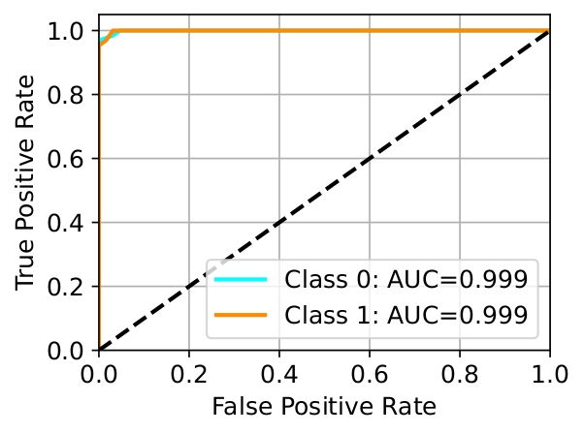
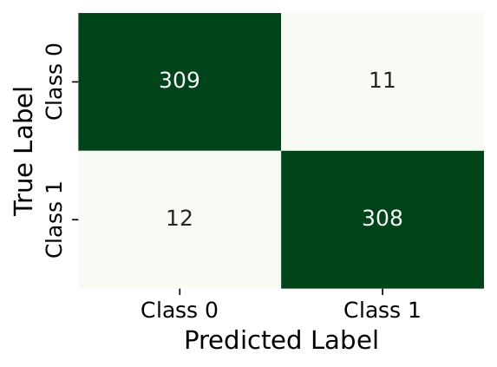

Fig 4.1: Decision Tree (DT)Confusion Matrix & ROC Curve.

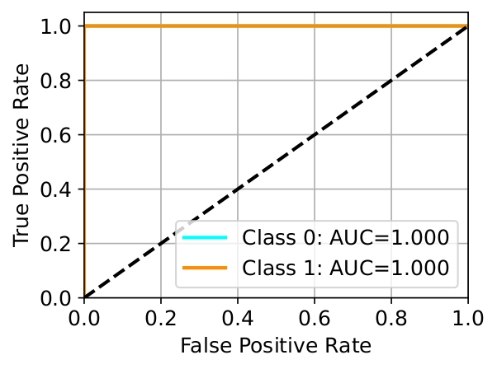
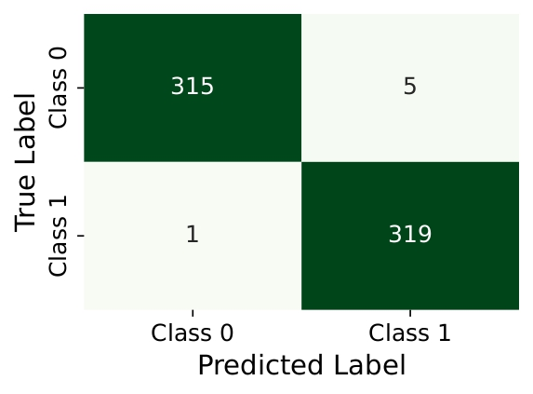

Fig 4.2: Extra Tree (ET)Confusion Matrix & ROC Curve.

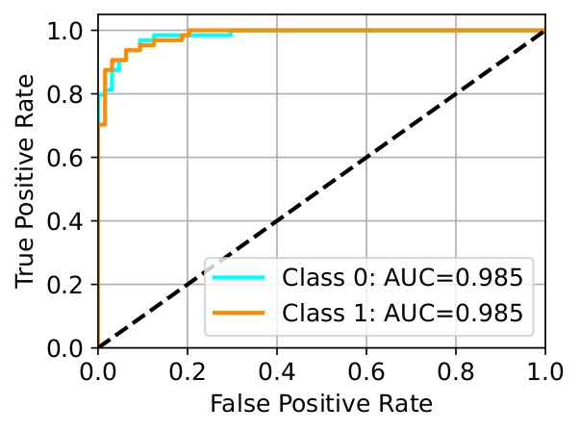
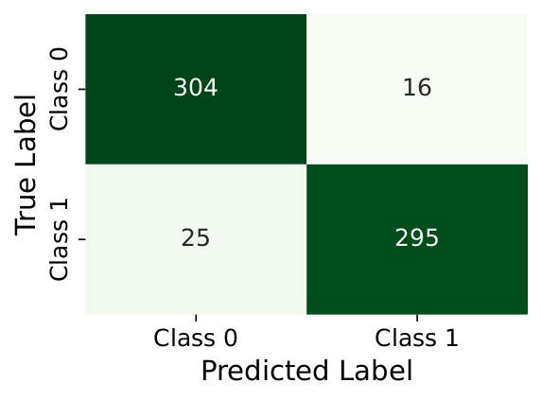

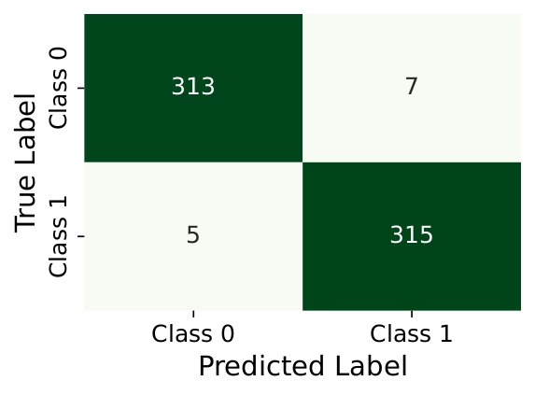
Fig 4.3: Logistic Regression (LR)Confusion Matrix & ROC Curve.

Fig 4.4: Random Forest (RF)Confusion Matrix & ROC Curve.
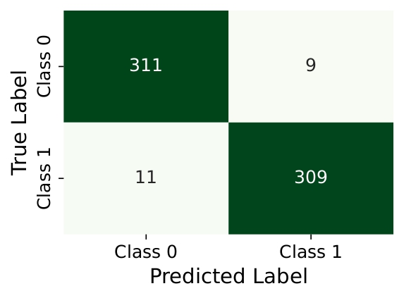

Fig 4.5: Support Vector Machines (SVM)Confusion Matrix & ROC Curve.

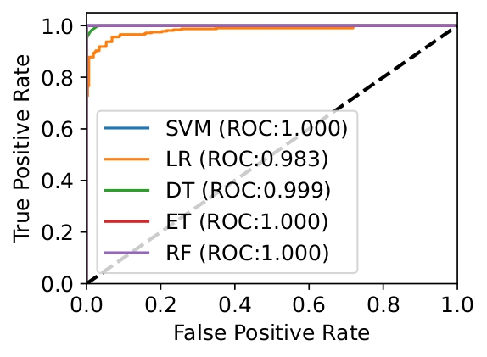

Fig 4.6: ROC Curve for All Classifier.

4.5 Explainable Artificial Intelligence (XAI)
Our study employs a two-fold explainability approach to demystify the black-box nature of the models and identify the most influential features contributing to predictions. This section outlines the methods used for interpreting the proposed classifier and determining key features affecting its decisions.

1) XAI for Interpreting Black-Box Models
To enhance transparency and understandability, we utilized four distinct explainability methods, each providing unique insights into model behavior and feature influence.
a) Shapley Additive Explanations (SHAP): SHAP values, derived from cooperative game theory, offer a robust framework for measuring the contribution of each feature to the predictions made by the model. The SHAP summary plot is instrumental in visualizing how features affect predictions across all classifiers. Each point on this plot corresponds to a specific instance's SHAP value, colored according to the feature's value (with red indicating higher values and blue indicating lower values). This visualization allows us to assess not only the importance of features but also their distribution and effect on predictions. The feature importance ranking is depicted with the y-axis representing features ranked by their overall importance based on the average absolute SHAP value, while the x-axis illustrates SHAP values, with positive values driving predictions toward class ‘1‘and negative values steering them toward class ‘0‘. Key findings indicate that “Polyuria” emerged as the most influential feature, significantly impacting predictions for class ‘1‘, followed by “Gender” and “Polydipsia.” In contrast, features like “Obesity” and “Weakness” exhibited lower influence, providing a clear picture of the model's reliance on specific attributes for decision-making (see Fig. 4.7). This granular breakdown helps stakeholders understand which features are pivotal in the model’s predictive capabilities, thus guiding further data collection or feature engineering efforts.
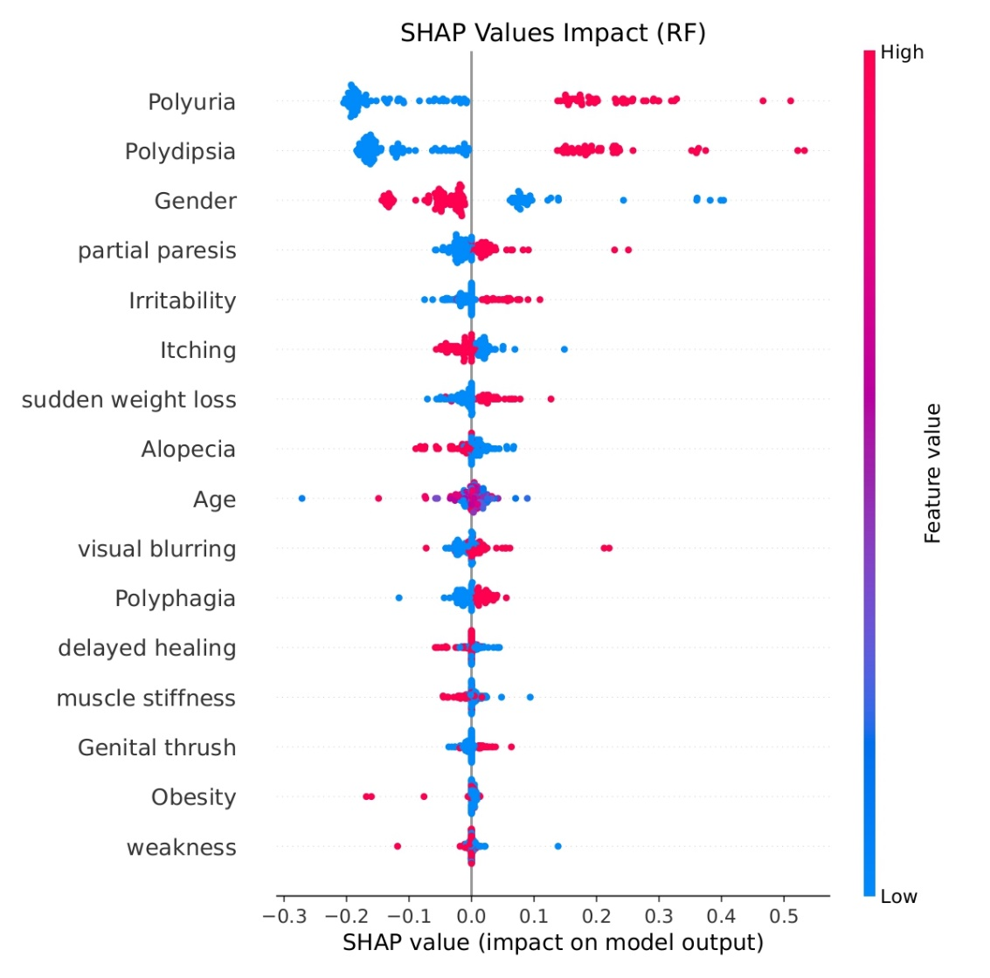
Fig. 4.7. SHAP Explanation (RF).
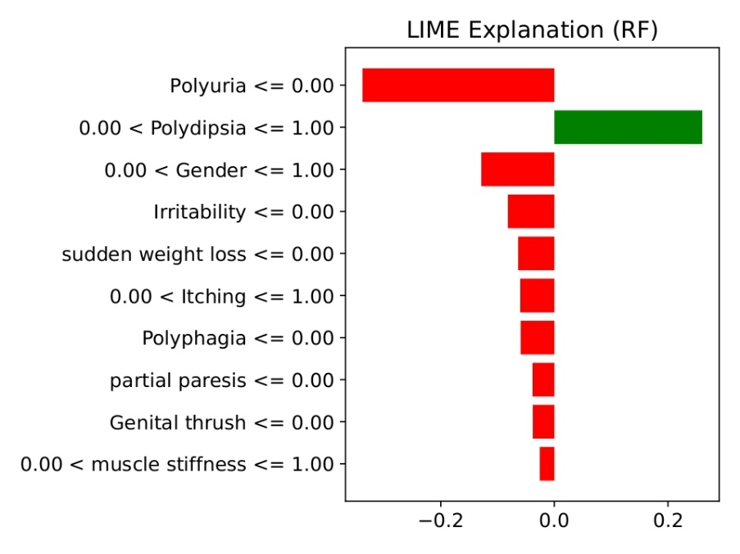
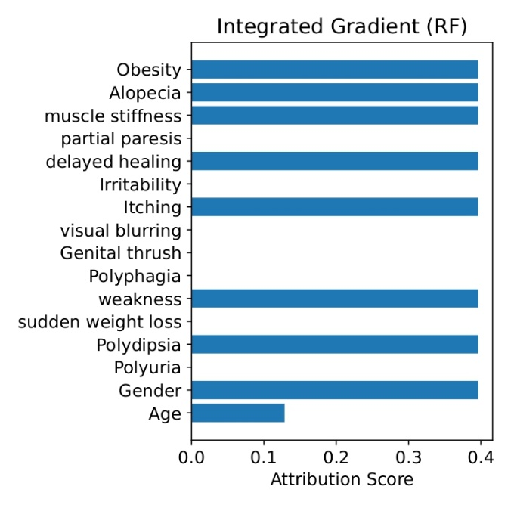
b) Local Interpretable Model-agnostic Explanations (LIME): LIME is designed to interpret complex models by approximating them with a simpler, interpretable model locally around a specific prediction. The LIME plot displays the attribution scores on the X-axis, revealing how each feature influences the model's predictions for individual instances. Bars extending to the right represent positive contributions towards class ‘1‘, while those extending to the left signify negative contributions towards class ‘0‘. These attribution scores are normalized using MinMax scaling, which ranges them between 0 and 1, allowing for standardized interpretation of feature influence. The LIME analysis highlighted features such as “Polyuria <= 0.00”, “Gender <= 1.00”, and “Sudden weight loss <= 0.00”, which pushed the prediction towards class ‘0‘. Conversely, “Polydipsia <= 1.00” had a positive contribution towards class ‘1‘. Notably, the Random Forest classifier achieved a high accuracy with a prediction probability of 0.98 for class ‘0‘, reinforcing the model's reliability in decision-making (see Fig. 4.8). This method enables stakeholders to better understand specific predictions and the rationale behind them, facilitating trust and transparency
Fig. 4.8. LIME Explanation (SVM). Fig. 4.9. Explanation by IG (RF)
c) Integrated Gradients (IG): Integrated Gradients assigns a score to each feature based on its contribution to the model’s output by evaluating the gradients of the model’s predictions. IG plots present the attribution scores vertically, indicating the level of each feature’s influence on the model’s predictions. Positive bars signify a positive influence, while negative bars indicate a negative impact. Results from the IG analysis demonstrate that features like “Obesity”, “Alopecia”, “Muscle stiffness”, and “Delayed healing” are significant positive contributors to predictions. Meanwhile, features like “Age” exhibit a moderate impact, while “Partial paresis”, “Visual blurring”, “Genital thrush”, “Polyphagia”, “Sudden weight loss”, and “Polyuria” show neutral or minimal influence on predicting class ‘0‘(see Fig. 4.9). This method not only enhances model transparency but also aids in feature selection for future iterations of the model.
d) Anchors: The Anchors method provides a rule-based explanation for the model’s predictions, focusing on specific conditions that lead to certain classifications. This approach leverages class names, feature names, and conditions for categorical features to elucidate the model’s decisions clearly. The Random Forest model, achieving a precision of 0.98, utilizes specific anchor conditions, such as “Polyuria” ≤ 0.00, “Irritability” ≤ 0.00, “Sudden weight loss” ≤ 0.00, “Genital thrush” ≤ 0.00, “Alopecia” (0.00 < x ≤ 1.00), and “Gender” (0.00 < x ≤ 1.00), for classifying instances accurately. These anchors enhance the model's reliability and interpretability, allowing users to grasp the underlying rationale behind the predictions made.

2) XAI for Feature Importance
In addition to the aforementioned methods, we employed two further techniques to assess the most influential features affecting the predictions of the proposed classifier.
a) Importance by Coefficients (ICE): Feature coefficients reveal their relative importance in the classifiers, with larger coefficients indicating a more significant influence on predictions. Fig. 4.10 illustrates the coefficient values for an RF model. Features with high coefficients tend to drive predictions towards class ‘1‘, while those with low coefficients influence predictions towards class ‘0‘. Features such as “Itching”, “weakness”, “Obesity”, and “muscle stiffness” exhibit lower coefficients, whereas “Polyuria”, “Polydipsia”, “Age”, and “Gender” demonstrate strong positive contributions. Features like “Alopecia” and “Polyphagia” show medium coefficients, suggesting moderate or potentially negative impacts on predictions.
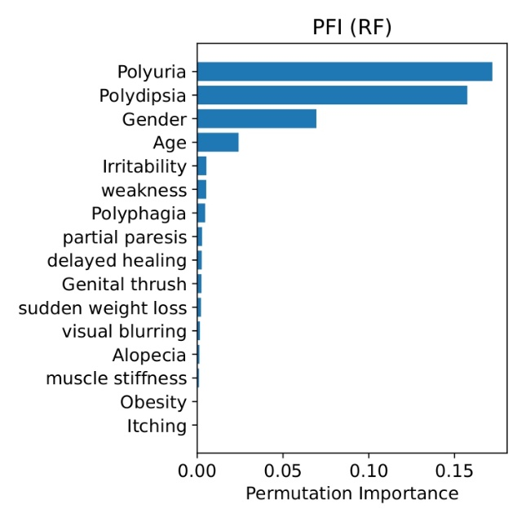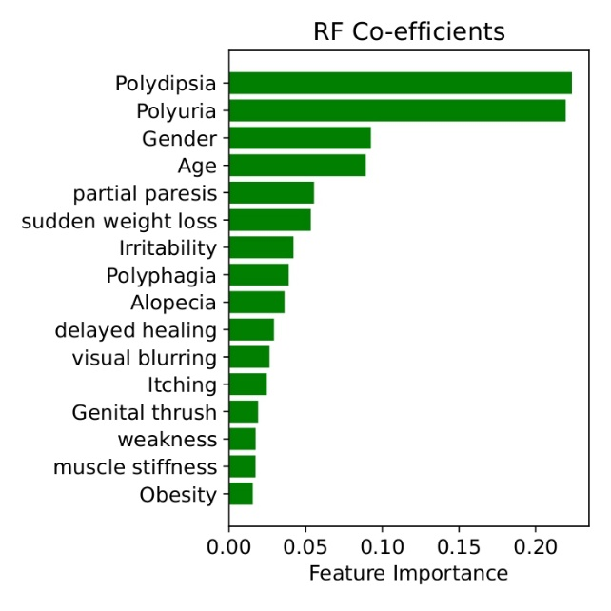
Fig. 4.10. ICE of RF Classifier. Fig. 4.11. PFI of RF Classifier.
b) Permutation Feature Importance (PFI): PFI assesses feature significance by measuring changes in model performance when feature values are randomly shuffled, thus evaluating their contributions in a more practical context. Fig. 4.11 illustrates the permutation importance for features in the RF classifier, presented in a bar plot with importance values ranging from 0.00 to 0.15. The analysis reveals that features such as “Polyuria”, “Polydipsia”, “Gender”, and “Age” stand out as the most influential, underlining their crucial roles in the model’s predictions. Conversely, features like “Itching”, “Obesity”, and “Muscle stiffness” exhibit lower importance, suggesting that they have limited effects on the overall performance of the model. This insight can inform future feature selection and model optimization efforts.

4.6 Discussion and Extended Comparison
This study assesses the performance of five machine learning classifiers for early-stage diabetes prediction using the Early Stage Diabetes Risk Prediction Dataset. Among them, the X-RF model stands out as the most effective, achieving an impressive accuracy of 98.59% and an F1-Score of 98.58%. The X-RF model excels in both precision and recall, underscoring its capability to manage complex, non-linear relationships and address class imbalance effectively. The use of various XAI techniques enhances the interpretability of the model, further supported by the evaluation of feature importance. Overall, the X-RF architecture’s exceptional accuracy and strong interpretability establish it as a leading choice for early-stage diabetes prediction. To substantiate the superiority of our approach, Table IV presents a thorough comparison with existing literature, focusing exclusively on studies that employed the same dataset as ours.

Table 4.7 Discussion and Extended Comparison
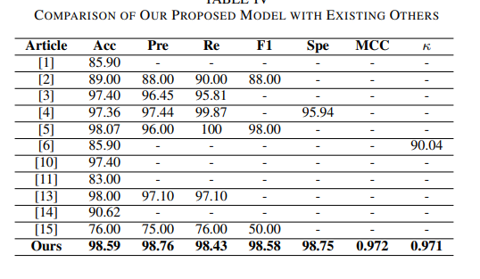

Chapter 5. Conclusion and Future Work

5.1 Conclusion
This study underscores the effectiveness of machine learning techniques, particularly the Explainable Random Forest (X-RF) model, in the early prediction of diabetes. Through a rigorous comparative evaluation of five classifiers—Random Forest (RF), Logistic Regression (LR), Support Vector Machine (SVM), Decision Tree (DT), and Extra Trees (ET)—the X-RF model consistently demonstrated superior performance, achieving an impressive accuracy of 98.59% and an F1-Score of 98.58%. These results affirm the model's reliability for early diabetes detection, a critical factor in clinical settings where timely intervention can significantly alter patient outcomes.
One of the standout features of the X-RF model is its robustness in handling complex relationships among features. Medical data in diabetes prediction often encompasses intricate interactions between risk factors, which traditional models like Logistic Regression struggle to accommodate due to their linear assumptions. In contrast, the X-RF model effectively captures non-linear relationships among variables such as age, gender, Body Mass Index (BMI), and lifestyle factors, enhancing its predictive power. This flexibility is further augmented by the ensemble nature of tree-based methods, which enables the model to perform exceptionally well in heterogeneous populations.
Another key strength of the X-RF model is its capacity to manage class imbalances prevalent in medical datasets. By employing techniques like stratified sampling and synthetic data generation methods, such as SMOTE (Synthetic Minority Over-sampling Technique), the model effectively addresses the challenge of under-representation of at-risk individuals. This balanced approach is critical in healthcare, where misclassifying potential diabetes cases can have severe implications for patient health.
The integration of Explainable Artificial Intelligence (XAI) techniques further enhances the model's interpretability. By utilizing methods such as SHAP (SHapley Additive exPlanations), LIME (Local Interpretable Model-agnostic Explanations), Anchors, and Integrated Gradients, the study provides valuable insights into the key predictors of diabetes risk. Notably, features like "Polyuria" and "Polydipsia" emerged as significant indicators, highlighting their importance in signaling underlying metabolic issues. Additionally, demographic factors such as "Age" and "Gender" were confirmed as vital components of the risk assessment.
The interpretability of the X-RF model empowers healthcare providers to engage in informed discussions with patients regarding their health. By elucidating how specific features contribute to risk predictions, the model encourages proactive health management. For example, healthcare providers can guide patients in monitoring symptoms like increased thirst and urination, fostering a more participatory approach to health management. Moreover, insights derived from the model can inform public health initiatives aimed at diabetes prevention, enabling targeted interventions in communities identified as high risk.
In summary, the X-RF model not only achieves high predictive accuracy but also fosters transparency and trust, making it an invaluable tool for guiding individuals at risk of diabetes toward proactive preventive measures. The potential impact of this work extends beyond individual patient care, offering insights into broader health disparities and guiding public health efforts aimed at mitigating the rising prevalence of diabetes.

5.2 Limitations
Despite the promising results of this study, several limitations warrant consideration.
- Dataset Limitations: The effectiveness of the X-RF model is contingent upon the quality and diversity of the datasets used. If the datasets lack representation from various demographic groups—including different ethnicities, ages, and geographical locations—this may hinder the model’s ability to generalize effectively. A more diverse dataset would help ensure that the model performs well across different population segments and reduces the risk of bias.
- Lack of Longitudinal Data: The absence of longitudinal data restricts the insights into how diabetes risk factors evolve over time. Without this temporal perspective, the model may miss crucial trends and changes that could enhance predictive accuracy. Longitudinal studies would provide a more comprehensive understanding of how risk factors interact and change over a patient's life course, improving the robustness of predictions.
- Interpretability Challenges: While the integration of XAI techniques like SHAP and LIME enhances interpretability, these methods may not capture all nuances of the model's decision-making process. The complexity of some machine learning models can lead to difficulties in fully understanding their predictions, which may limit their acceptance in clinical practice. Simplifying these explanations for non-technical users remains a challenge.
- Potential for Model Overfitting: The X-RF model's high accuracy could raise concerns about overfitting, especially if it is trained on a limited dataset. Overfitting occurs when a model learns noise and fluctuations in the training data rather than the underlying patterns, leading to poor performance on unseen data. Continuous validation and testing against new data will be essential to ensure the model's robustness.
- Implementation Barriers: Translating the model's capabilities into clinical practice poses practical challenges. Ensuring that healthcare providers can effectively use the model within their existing workflows requires user-friendly interfaces and thorough training. Overcoming resistance to adopting new technologies in healthcare settings may also present a significant hurdle.

5.3 Future Work
To further enhance the predictive capabilities and applicability of machine learning models for diabetes prediction, several key areas of research are vital:
- Expansion of Diverse Datasets: Future studies should prioritize the integration of diverse datasets that encompass a wide range of demographic variables, including ethnicities, age groups, and geographical regions. This inclusivity will enhance the model's robustness and generalizability across various populations. Moreover, utilizing longitudinal datasets will allow researchers to analyze how risk factors change over time, providing deeper insights into diabetes progression.
- Advanced Explainable AI Techniques: Incorporating additional XAI methodologies is essential for providing comprehensive insights into model behavior. Techniques such as Counterfactual Explanations can help identify how different feature values would alter predictions, enhancing understanding of model sensitivity. Expanding the toolkit of XAI methods will bolster user trust and acceptance, particularly in sensitive healthcare applications.
- Model Generalizability: Enhancing the generalizability of the X-RF model is crucial for accommodating a broader array of diabetes risk factors and patient profiles. Implementing transfer learning techniques, where the model is trained on one dataset and fine-tuned on another, can facilitate adaptation to new environments. Additionally, developing ensemble models that integrate predictions from multiple algorithms may further improve overall accuracy and reliability.
- Incorporating Clinical Insights and User Feedback: Collaborating with healthcare professionals is essential to align the model with clinical workflows. Engaging end-users can provide valuable perspectives on the most relevant features for prediction and identify potential barriers to implementation. Their input can guide the development of the model, ensuring it meets the needs of practitioners and patients.
- User-Friendly Interfaces: The development of intuitive and accessible user interfaces is critical for the practical application of the X-RF model in clinical settings. These interfaces should clearly present predictions and insights, facilitating understanding for both healthcare providers and patients. Features such as risk factor visualizations and personalized recommendations can enhance usability and encourage proactive health management.
- Longitudinal Studies and Clinical Trials: Conducting longitudinal studies and clinical trials will be crucial for validating the X-RF model in real-world settings. These studies can assess the model's effectiveness across diverse populations and clinical environments, providing empirical evidence to support its use in preventive healthcare.
- Integration with Other Health Technologies: Future research should explore the integration of the X-RF model with other health technologies, such as wearable devices and mobile health applications. This integration can facilitate continuous monitoring of risk factors and enhance patient engagement through real-time feedback.

5.4 References

- L. Kopitar, P. Kocbek, L. Cilar, A. Sheikh, and G. Stiglic, “Early detection of type 2 diabetes mellitus using machine learning-based prediction models,” Scientific Reports, vol. 10, no. 1, p. 11981, 2020.
- H. Kaur and V. Kumari, “Predictive modelling and analytics for diabetes using a machine learning approach,” Applied Computing and Informatics, vol. 18, no. 1/2, pp. 90–100, 2022.
- A. Yaşar, “Data classification of early-stage diabetes risk prediction datasets and analysis of algorithm performance using feature extraction methods and machine learning techniques,” International Journal of Intelligent Systems and Applications in Engineering, vol. 9, no. 4, pp. 273–281, 2021.
- D. S. Khafaga, A. H. Alharbi, I. Mohamed, and K. M. Hosny, “An integrated classification and association rule technique for early-stage diabetes risk prediction,” in Healthcare, vol. 10, p. 2070, MDPI, 2022.
- N. Elsayed, Z. ElSayed, and M. Ozer, “Early stage diabetes prediction via extreme learning machine,” in SoutheastCon 2022, pp. 374–379, IEEE, 2022.
- V. Wijayaningrum, T. Saragih, and N. Putriwijaya, “Optimal multi-layer perceptron parameters for early stage diabetes risk prediction,” in IOP Conference Series: Materials Science and Engineering, vol. 1073, p. 012070, IOP Publishing, 2021.
- Ö. N. Ergün et al., “Early stage diabetes prediction using machine learning methods,” AvrupaBilimveTeknolojiDergisi, no. 29, pp. 52–57, 2021.
- M. Zarar and Y. Wang, “Early stage diabetes prediction by approach using machine learning techniques,” 2023.
- V. Vakil, S. Pachchigar, C. Chavda, and S. Soni, “Explainable predictions of different machine learning algorithms used to predict early stage diabetes,” arXiv preprint arXiv:2111.09939, 2021.
- A. Y. Abushawish and A. B. Nassif, “Prediction of early-stage diabetes using machine learning,” in 2023 Advances in Science and Engineering Technology International Conferences (ASET), pp. 1–4, IEEE, 2023.
- M. A. R. Refat, M. Al Amin, C. Kaushal, M. N. Yeasmin, and M. K. Islam, “A comparative analysis of early stage diabetes prediction using machine learning and deep learning approach,” in 2021 6th International Conference on Signal Processing, Computing and Control (ISPCC), pp. 654–659, IEEE, 2021.
- S. Gündoğdu, “Efficient prediction of early-stage diabetes using xgboost classifier with random forest feature selection technique,” Multimedia Tools and Applications, vol. 82, no. 22, pp. 34163–34181, 2023.
- U. E. Laila, K. Mahboob, A. W. Khan, F. Khan, and W. Taekeun, “An ensemble approach to predict early-stage diabetes risk using machine learning: An empirical study,” Sensors, vol. 22, no. 14, p. 5247, 2022.
- S. Samet, M. R. Laouar, and I. Bendib, “Diabetes mellitus early stage risk prediction using machine learning algorithms,” in 2021 International Conference on Networking and Advanced Systems (ICNAS), pp. 1–6, IEEE, 2021.
- X. Chen, S. Zhou, L. Yang, Q. Zhong, H. Liu, Y. Zhang, H. Yu, and Y. Cai, “Risk prediction of diabetes progression using big data mining with multifarious physical examination indicators,” Diabetes, Metabolic Syndrome and Obesity, pp. 1249–1265, 2024.
- “Early stage diabetes risk prediction - UCI Machine Learning Repository.”https://archive.ics.uci.edu/dataset/529/early+stage+diabetes+risk+prediction+dataset (Accessed on 09/01/2024).

